stmarys2



**St Mary's Anglican Girls' School**

**Semester Two, 2010**

**Question/Answer Booklet**

**MATHEMATICS**

**Year 12 3C/3D**

**Section Two:**

**Calculator-assumed**

**Time allowed for this section**

Reading time before commencing work: 10 minutes

Working time for this section: 100 minutes

**Material required/recommended for this section**

***To be provided by the supervisor***

This Question/Answer Booklet

Formula Sheet (retained from Section One)

***To be provided by the candidate***

Standard items: pens, pencils, pencil sharpener, eraser, correction fluid, ruler, highlighters

Special items: drawing instruments, templates, notes on two unfolded sheets of A4 paper, and up to three calculators satisfying the conditions set by the Curriculum Council for this course.

**Important note to candidates**

No other items may be taken into the examination room. It is **your** responsibility to ensure that you do not have any unauthorised notes or other items of a non-personal nature in the examination room. If you have any unauthorised material with you, hand it to the supervisor **before** reading any further.

**Structure of this paper**

|  |  |  |  |  |
| --- | --- | --- | --- | --- |
| Section | Number of questions available | Number of questions to be answered | Working time (minutes) | Marks available |
| Section One:  Calculator-free | 8 | 8 | 50 | 40 |
| **Section Two:**  **Calculator-assumed** | **13** | **13** | **100** | **80** |
|  |  |  |  | 120 |

**Instructions to candidates**

1. Write your answers in the spaces provided in this Question/Answer Booklet. Spare pages are included at the end of this booklet. They can be used for planning your responses and/or as additional space if required to continue an answer.

* + Planning: If you use the spare pages for planning, indicate this clearly at the top of the page.
  + Continuing an answer: If you need to use the space to continue an answer, indicate in the original answer space where the answer is continued, i.e. give the page number. Fill in the number of the question(s) that you are continuing to answer at the top of the page.

2. **Show all your working clearly.** Your working should be in sufficient detail to allow your answers to be checked readily and for marks to be awarded for reasoning. Incorrect answers given without supporting reasoning cannot be allocated any marks. For any question or part question worth more than two marks, valid working or justification is required to receive full marks. If you repeat an answer to any question, ensure that you cancel the answer you do not wish to have marked.

3. It is recommended that you **do not use pencil** except in diagrams.

9. [3 marks]

When air is released from an inflated balloon it is found that the rate of decrease of the volume of the balloon is proportional to the volume of the balloon. This can be represented by the differential equation  = – *kv*, where *v* is the volume (in cm3), *t* is the time (in seconds) and *k* is the constant of proportionality.

(a) If the initial volume of the balloon is *v*0, find an expression, in terms of *k*, for the volume of the balloon at time *t*. (1)

(b) If it takes 20 seconds for the volume to halve, find *k*. (2)

10. [7 marks]

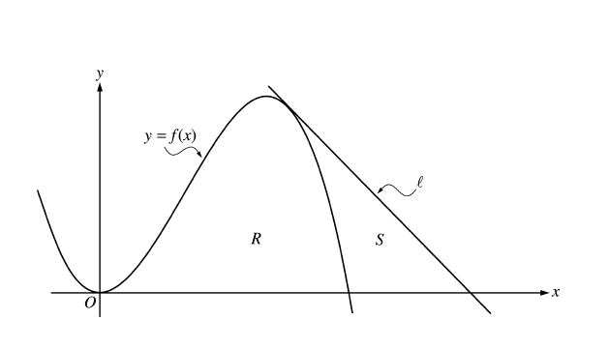

(3, 9)

Let *f* be the function given by , and let *l* be the tangent to the graph of *f*.

(a) Show that *l* has equation  (3)

Let *S* be the region bounded by the graph of *f*, the line *l*, and the *x*-axis, as shown on the previous page.

(b) Find the area of *S*. (4)

11. [9 marks]

Josie travels to school on a bus. On any day, the probability that Josie will miss the bus is . If she misses the bus, the probability that she will be late to school is .

Let *M* be the event “she misses the bus” and *L* the event “she is late for school”.

.

(a) Represent this information on a tree diagram.   
Show all probabilities on the branches of the tree. (3)

(b) Find the probability that

(i) Josie catches the bus and is not late for school, (1)

(ii) Josie misses her bus, given that she is late for school. (2)

The cost for each bus journey is $1. Josie goes to school on Monday and Tuesday. If she misses the bus she must walk to school. She always gets a lift home from school.

(c) Complete the probability distribution table. (2)

|  |  |  |  |
| --- | --- | --- | --- |
| *X* (Cost in dollars) | 0 | 1 | 2 |
| P(*X*) |  |  |  |

(d) What is the expected cost for Josie’s bus trips on Monday and Tuesday? (1)

12. [9 marks]

A satellite relies on solar cells for its power and will operate provided that at least one of the cells is working. Cells fail independently of each other, and the probability that an individual cell fails within one year is 0.8.

(a) For a satellite with ten solar cells, find the probability that more than 6 cells have failed within the year. (2)

(b) For a satellite with *n* solar cells, find the smallest number of solar cells required so that the probability of the satellite still operating at the end of one year is at least 0.95. (3)

(2)

The lifetime of a particular component of a solar cell is *Y* years, where *Y* is a continuous random variable with probability density function



(c) Find the probability that a given component fails within six months.

(2)

Each solar cell has three components which work independently and the cell will continue to run if at least two of the components continue to work.

(d) Find the probability that a solar cell fails within six months.

(3)

13. [6 marks]

Follow these instructions:

* Choose any counting number greater than 1.
* Cube it.
* Subtract the original number.
* Double your answer.

(a) When you follow the instructions, what is the largest number that the answer must   
be divisible by? (1)

(b) Propose a conjecture using algebraic notation and then prove it. (5)

14. [4 marks]

The marginal cost ($) for a refrigerator company producing *x* refrigerators per day is:



(a) Find . (1)

(b) Interpret your answer to (a) in the context of this problem. (1)

(c) Show how to use the incremental formula to approximate the value you found in (a). (2)

15. [12 marks]

(a) At a building site the probability, P(*A*), that all materials arrive on time is 0.85. The probability, P(*B*), that the building will be completed on time is 0.60. The probability that the materials arrive on time and that the building is completed on time is 0.55.

(i) Show that events *A* and *B* are **not** independent. (2)

(ii) All the materials arrive on time. Find the probability that the building will not be completed on time. (3)

(b) There was a team of ten people working on the building, including three electricians and two plumbers. The architect called a meeting with five of the team, and randomly selected people to attend. Calculate the probability that **exactly two** electricians and **one** plumber were called to the meeting. (3)

(c) The number of hours per week the people in the team work is normally distributed with a mean of 42 hours. 10% of the team work 48 hours or more a week. Find the probability that **both** plumbers work more than 40 hours in a given week.

(4)

16. [4 marks]

The graph below shows the region satisfying the following inequalities:





A

B

C

D

The vertices of this region are A(0,18), B(4, 16), C(8,12) and D(16,0).

The profit (*P*) on each unit of *x* is $6 and on each unit of *y* is $5.50*.*

Point C maximises this profit.

By how much can the profit on each unit of *y* decrease before C is no longer the optimal solution?

17. [6 marks]



*AB* is a diameter of the circle. The tangents at *A* and *C* meet at *T*. The lines *TC* and *AB* are produced to meet at *P*.



Prove:

Extension to diagram: Join *AC*, *BC*

Proof: Let 

18. [6 marks]

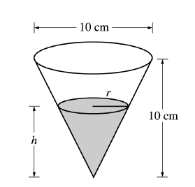

A container has the shape of an open right circular cone, as shown in the figure above. The height of the container is 10 cm and the diameter of the opening is 10 cm. Water in the container is evaporating so the depth *h* is changing at the constant rate of cm/h.

(a) Find the volume *V* of the water in the container when *h* = 5 cm. (2)  
Indicate units of measure.

(b) Find the rate of change of the volume of water in the container, with respect to time, when *h* = 5 cm. Indicate units of measure. (4)

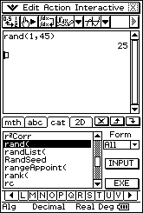19. [5 marks]

Suppose that the random number generator on your calculator was programmed to print whole numbers from 1 to 45 inclusive.

(a) If this was done many times, and probabilities calculated, what distribution   
would you expect? Explain your reasoning. (1)

The mean of this distribution is 23 and the standard deviation is 12.99 (2 d.p).

Suppose now that the calculator is programmed to simulate the selection of 6 numbers from   
1 – 45 (without repetition) as required to win in Weekend Lotto.

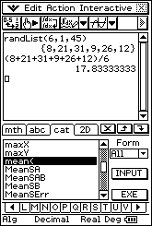

It is done 100 times and the mean of the 6 numbers is calculated each time.

(b) To what distribution would the means approximate? State the statistics that define this distribution. (3)

(c) What is the probability that your chosen 6 numbers win the Lotto draw? (1)

20. [5 marks]

The following diagram shows the graphs of the horizontal displacement, velocity and acceleration of a moving object as functions of time, *t.*

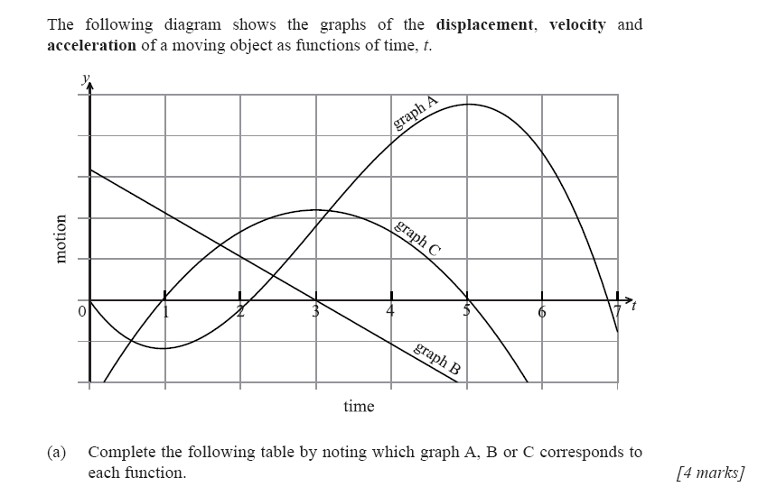

(a) Complete the following table by noting which graph A, B or C corresponds to each function.

(1)

|  |  |
| --- | --- |
| Function | Graph |
| displacement |  |
| acceleration |  |

(b) When is the object turning around? (1)

(c) When is the object to the left of the origin but moving towards the right? (1)

(d) When is the object speeding up? (2)

21. [4 marks]

A chicken farmer wishes to find a confidence interval for the mean weight of his chickens. He therefore randomly selects *n* chickens and weighs them. Based on his results, he obtains the following 95% confidence interval.

[2148 grams, 2188 grams]

The weights of the chickens are known to be normally distributed with a standard deviation of   
100 grams.

Find the value of *n.*

*End of Paper*

Additional Working Space

Additional Working Space

Additional Working Space

Additional Working Space